**Lab 2: ES50 Section 007, Lombardo Thursday 6:30 pm – 9:30 pm**

**Name: Nabib Ahmed, Sharanya Pulapura, Andrew Jiang**

**2: Pre-lab questions:**

1. We all read the lab.
2. We all watched the video.
3. Graphs are on the separate piece of paper. For a resistor, the IV-curve follows from Ohm’s Law since the variables are proportional. For the LED, there is a “forward potential”, or threshold potential, that is required until current shoots upward. ````````````
4. For both devices, if a high enough voltage is applied, the LED or resistor might overheat and pop. If the voltage is negative, the same applies to the resistor. For the LED, however, since it is a diode and transmits current only in one direction, it will pop or overheat.

**3. IV Characteristic Curves of Resistors and LEDs**

1. The graph and calculation for RX is on the separate sheet.  
   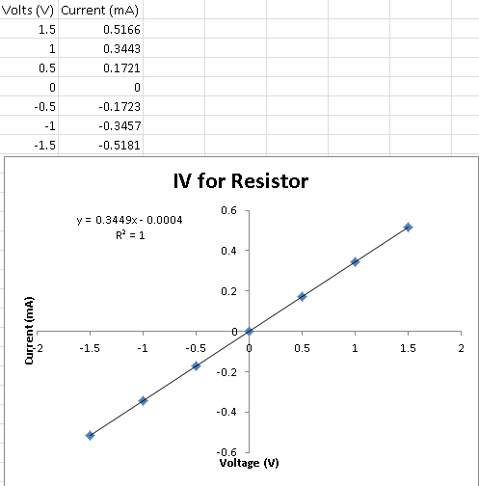 The slope of the graph gives the inverse of resistance, since RX = V/I. Thus, 1/0.3449 = 2.9 kΩ. The actual resistance according to the multimeter is 2.7 kΩ.
2. These data deviates a bit form the curve, with the ratio for RX being closer to 2.7 kΩ as we increased the voltage either way.
3. We were unable to find a best fit curve on Excel for this graph, as Joy confirmed. 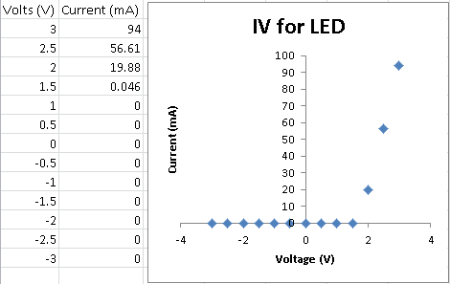
4. For +6V, the LED became hot and the light went off, showing overheat in power. The initial current was over 200 mA, but quickly decreased after overheat. This falls in line with our graph because it represents the exponential increase. For -6V, there was once again no current through the system, which falls in line with the other negative voltages on the graph.

**4. KVL, KCL, and Superposition (With R1=R2=R3=1 kΩ, and V1 = 5V)**

1. The biggest loop clockwise has voltage through V1 = -1.78 V, voltage through R1 = 2.26 V, and voltage through R3 = -0.48 V. KVL holds as the sum is zero. The right loop clockwise has voltage through V1 = -1.78 V, voltage through R1 = 2.26 V, voltage through R2 = 2.74 V, and voltage through V2 = -3.22 V. KVL holds as the sum is zero. The left loop clockwise has voltage through R2 = 2.74 V, voltage through R3 = -0.48 V, and voltage through V2 = -3.22 V. KVL holds as the sum is zero. We picked the biggest loop to measure in the counter clockwise direction. The biggest loop counter clockwise has voltage through V1 = 1.78 V, voltage through R1 = -2.26 V, and voltage through R3 = 0.48 V. KVL holds as the sum is zero. Thus KVL holds regardless of direction.
2. See diagram on sheet for the reference direction for current I­2. We measured this current to be 2.73 mA. The positive value means that our reference direction corresponds with conventional current direction. When we measured in the opposite reference direction, we got -2.73 mA.
3. See diagram for the current directions from node N. We measured I­1 as 2.24 mA, I­2 as 2.73 mA, and I3 as -0.43 mA. Accounting for directions, we have that the current exiting the node is the same as the current entering the node. Thus, this confirms that KCL holds.

**5. Voltage Divider (With R1=R2=1 kΩ, and V = 5V)**

1. Without the load resistor RL, the voltage across AB = 2.5 V. With RL closer to R2 (RL = R2 = 1 kΩ), the voltage across AB = 1.67 V. With RL closer to zero, the voltage across AB = 0 V. With RL farther from R2 (RL = 5 kΩ), the voltage across AB = 2.20 V.

|  |  |  |
| --- | --- | --- |
| **Load Resistor RL­** | **Actual Measurements** | **Expected Value** |
| None | 2.5 V | 2.5 V |
| 1 kΩ | 1.67 V | 1.67 V |
| 0 Ω | 0 V | 0 V |
| 5 kΩ | 2.20 V | 2.27 V |

There are no substantial differences between actual and expected values.

The only cases where the voltage divider acts like an ideal source are when the load resistance is 0 kΩ or has infinite resistance.

1. When we twist the potentiometer knob, the voltage increases from 0V to 10V. Using a higher resistance potentiometer will allow the results to be more precise, since there is a greater range of values that R1 can be by shifting the knob. This also allows it to be more power-resistant so it is less likely to overheat or pop. The range from 0V to 10V will remain the same.
2. When we turn the power on, the voltage almost immediately increases to 5V. Once we turn off the power supply, the voltage exponentially decreases as it discharges until it reaches 0V.